Kind Keeper Animal Rescue  Annual Golf Tournament  When  February 19th 2022  9AM Registration  10AM Shotgun Start  Where  Crown Park Golf Club  2225 Hwy 9 W, Longs, SC 29568  Eligibility: The field is limited to the first 30 PAID Teams of Four players  If you don’t have a team of four we can try to pair you with one. Please send us an email.  Format: All will play a 4-person Captain’s Choice  Awards: Prizes will be awarded to the top 3 finishing teams  All proceeds benefit kind keeper animal rescue  Donations of puppy chow or kitten chow are always appreciated! | Registration fee  $55 Per Player  includes  Greens  Cart Fee  Range Balls  Breakfast  Lunch  $20 Gift Card to PGA Store  Sign up  Registration forms can be found at kindkeeper.org  Questions?  Please email events.kindkeeper @yahoo.com  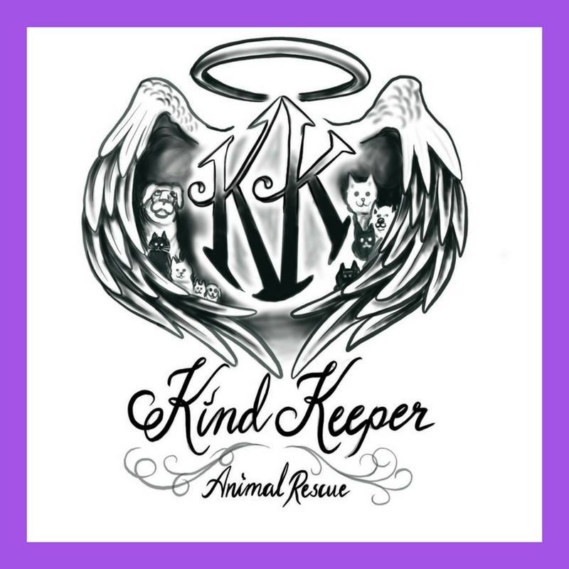  Details & Updates can be found on our website!

