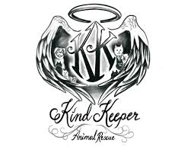
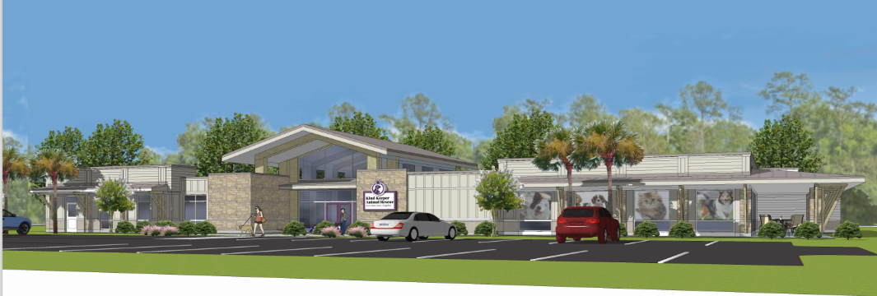

KIND KEEPER ANIMAL RESCUE GOLF TOURNAMENT
Benefiting Kind Keeper Animal Rescue New Building Fund
Saturday, February 19th 2022 at Crown Park Golf Club
9:00am Registration * 10:00am Shotgun Start
ENTRY -REGISTRATION FEE: $55 per player Registration Fee (and optional donation of 20lb bag of puppy chow or kitten chow) Registration includes Greens and Cart Fee, range balls, breakfast, lunch, and $20 gift certificate for the PGA Store.
ELIGIBILITY: Anyone who loves golf and animals. The field is limited to the first 30 PAID teams
FORMAT & AWARDS All Contestants will play a four person Captain’s Choice
Prizes will be awarded to the top three finishing teams
(There are no “flights” in this event. Everyone is competing in the same field.)
CONTACTS: Belinda Mairowicz 843-427-4388
Ray Park 843-742-5183
HOST: Rob Lane 843-756-3200
ENTRY DEADLINE SATURDAY FEBRUARY 11TH 2022 OR UNTIL FULL
Please forward your entry fee and team members’ information as soon as possible
**YOUR REGISTRATION FEE MUST BE PAID IN ADVANCE TO PLAY IN THE TOURNAMENT

Please Print Clearly
BIG DOG: _______ PHONE# EMAIL ADDRESS_______________

LITTLE PUPPY: _____PHONE# EMAIL ADDRESS________

LITTLE PUPPY: _____PHONE# EMAIL ADDRESS

LITTLE PUPPY: _____PHONE# EMAIL ADDRESS
EMAIL THIS FORM TO EVENTS.KINDKEEPER@YAHOO.COM AFTER ONLINE PAYMENT IS COMPLETE
OR
MAIL ENTRY FORM AND MAKE CHECKS PAYABLE TO: Kind Keeper Animal Rescue @1500 LD Drive North Myrtle Beach 29582

